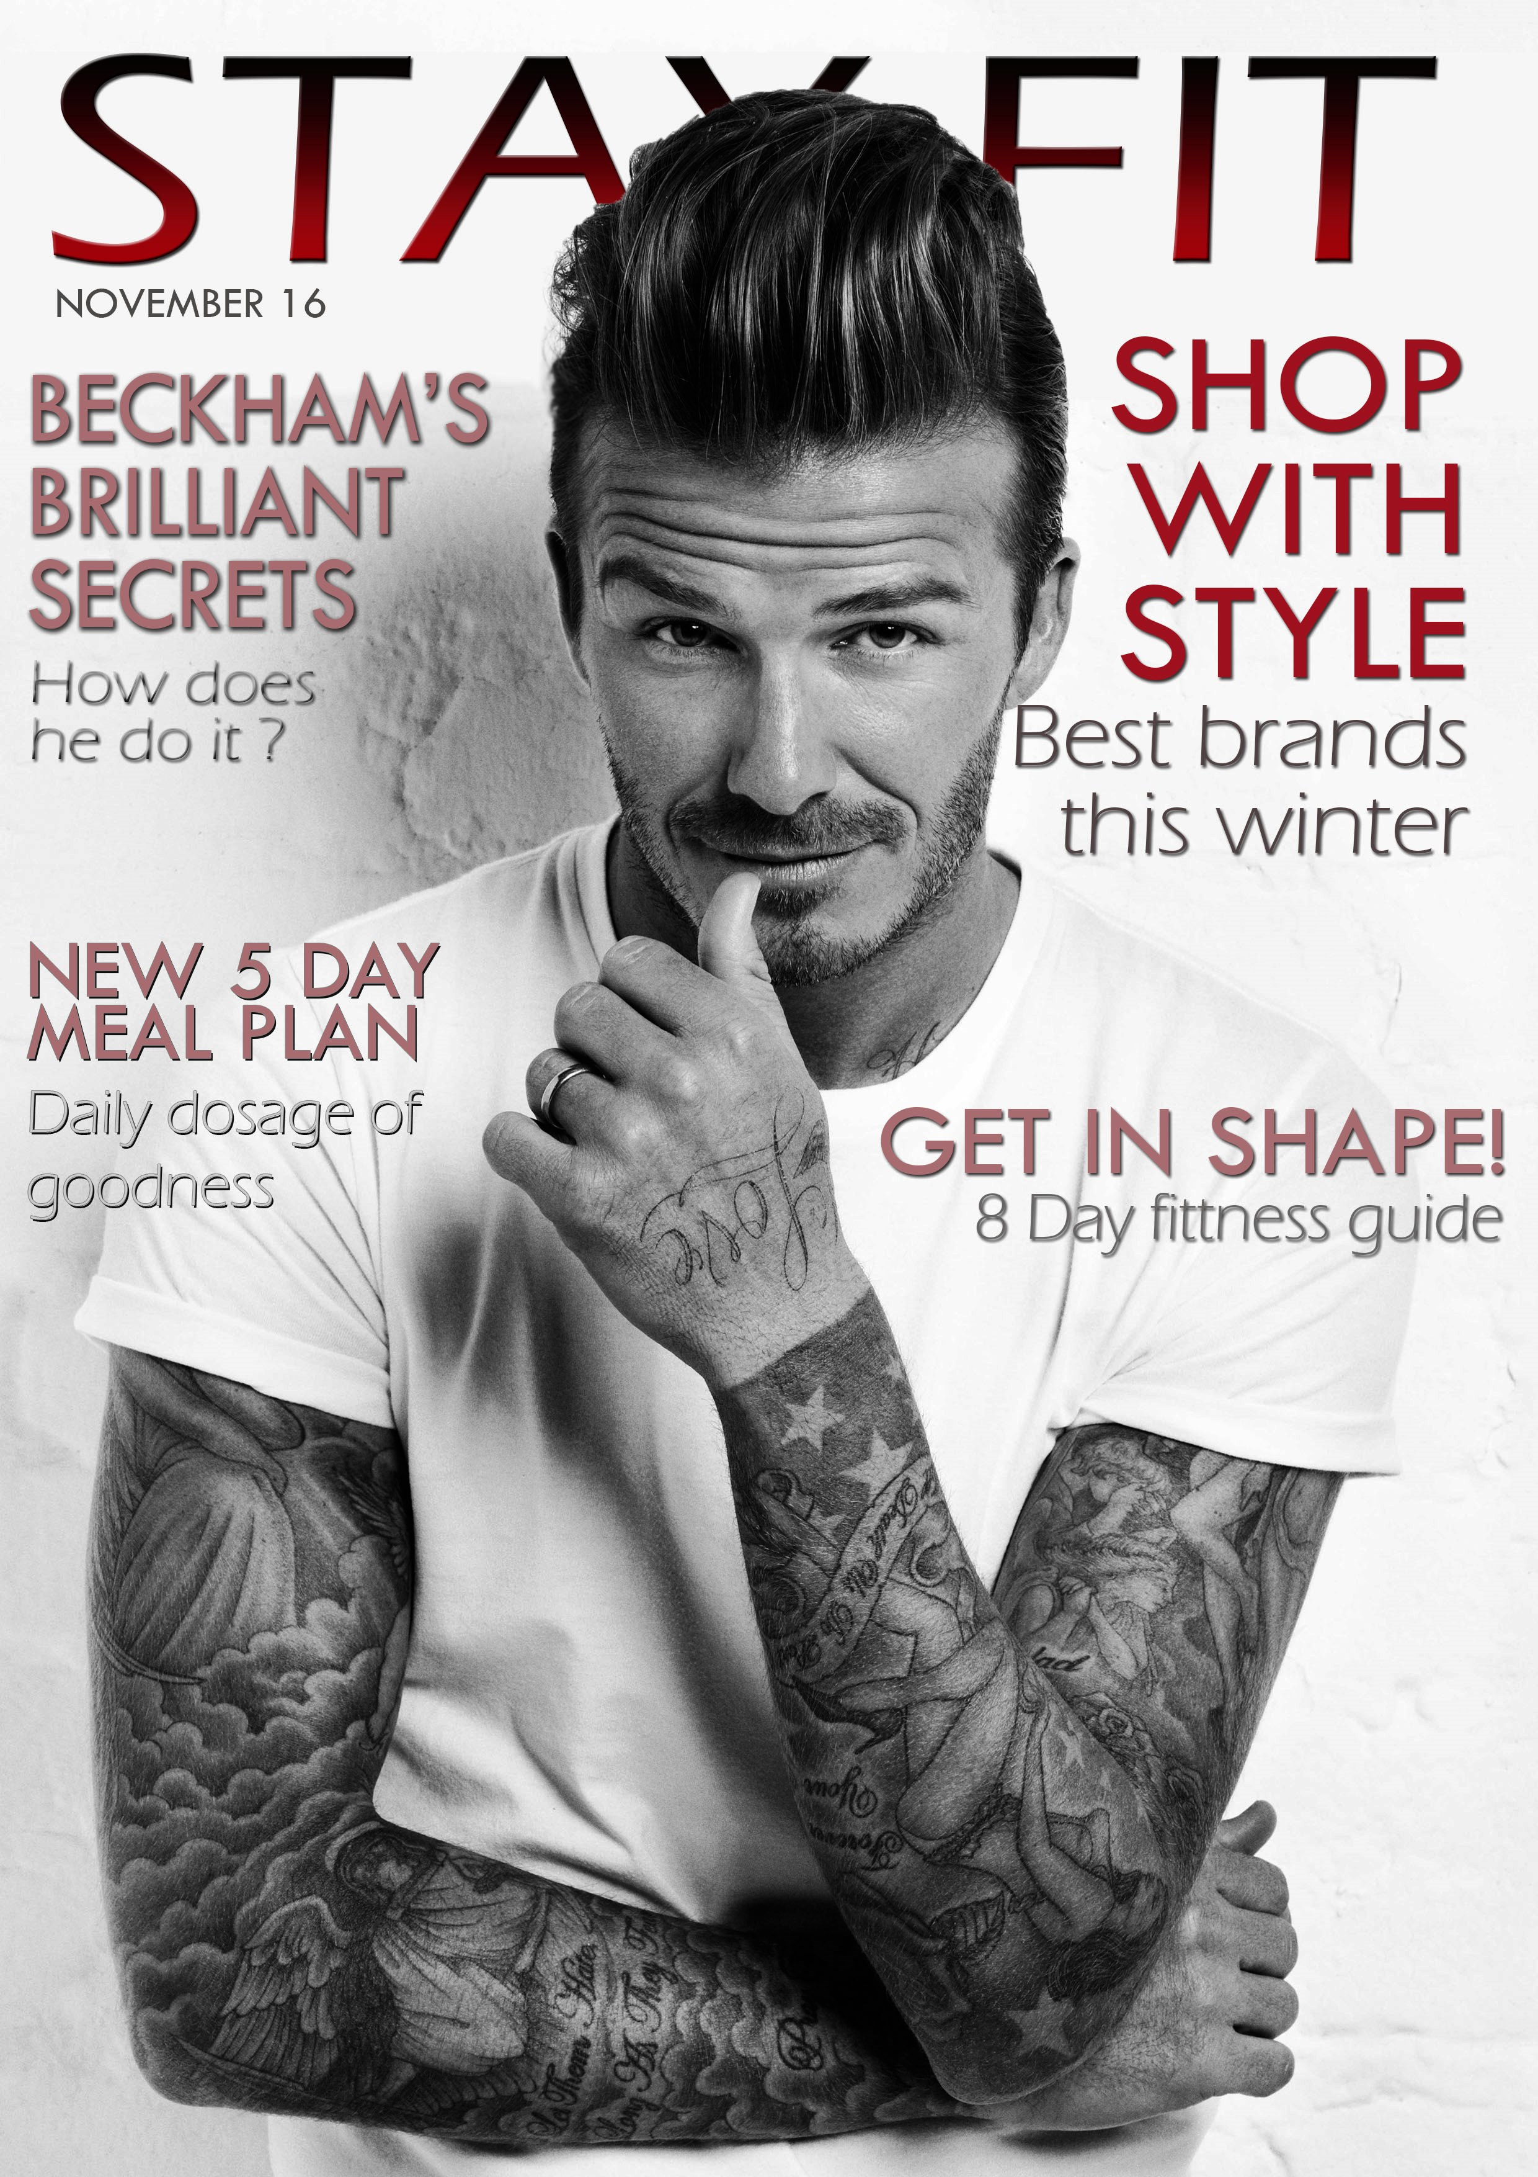
Masthead
The words ‘stay fit’, tell the audience that the genre of the magazine is a men’s fitness magazine. I chose to have the masthead in a bold but stylish font with a red and black ombre. The use of the bold font and the red and black colour palette complement each other and connote strength and power which makes the cover more appealing to my target audience as they would read my magazine in order to become stronger.

Colour pallet
Background colour is white suggesting innocence and purity; it is also a good background colour as it makes my sell lines stand out more, so as to direct the TA’s eye to the important information. I have used red and a lighter peachy colour for the sell lines and anchorage text because they work with the title to connote strength but the peach colour makes it clear for the demographic to establish the main headings of the issue. I chose not to use black for the less important parts of the sell lines as black was too bold and reflected the title too much.
Sell lines
Displayed in the left and right third so they are more spread out and evenly balanced. Highlights the most important and appealing parts of the magazine so they stand out to the demographic when on show in a shop. The use of having ‘Shop with style’ in red makes the TA pay attention to that specific page number.
‘Best brands this winter’ this reinforces the date of the magazine and people know that the magazine is going to contain some fashion tips for dressing like stars like David Beckham. This would appeal to the demographic as some readers would be aspiring to be like Beckham.
Anchorage text
The word ‘Beckham is in line with Beckham’s head on the left third of the cover, this is so that when displayed on the shelf in a shop, the audience will see Beckham and will be drawn to the magazine. The anchorage text is directly underneath the masthead so if the demographic are looking at the cover then they will not miss it. ‘How does he do it?’ this leaves the audience with an enigma ‘do what?’ making them want to read the magazine and read on.
Main image
A mid-shot of David Beckham appeals to the target audience, because he is well known worldwide and the target audience aspires to be like him. Stance and costume is simplistic and reveals his tattooed biceps, this reinforces how he is stereotypically seen by the public as a strong and stylish figure. By styling his hair up makes it look natural but it also emphasizes his face making him attractive to a female audience. Direct address is used through his facial expression to make the image more personal for the demographic. His costume denotes a plain white t-shirt that blends with the background. The white suggests that he is innocent and perfect but still sophisticated. Against the plain white of the background and T-shirt, puts a lot of emphasis on Beckham’s tattoos, they contrast with the white to make them look neat and stylish, opposing the idea that he is innocent and perfect as tattoo are typically associated with rebels and troublemakers.
Audience
The magazine is intended for young men from ages 18-40. Target audience would be interested in fitness magazines like ‘Men’s Health’ and ‘Men’s Fitness’. [Burton’s theory of media grouping]
The demographic would read ‘Stay Fit ’ magazine for identity and information as well as escapism [Uses and gratification Theory].

